Stage 2 – Any Port In A Storm
COURSE DESIGNER: Ryan Christenson
SCORING: Comstock 30 rounds.
TARGETS: 15 cardboard targets
SCORED HITS: 2 Best hits per carboard will be scored.

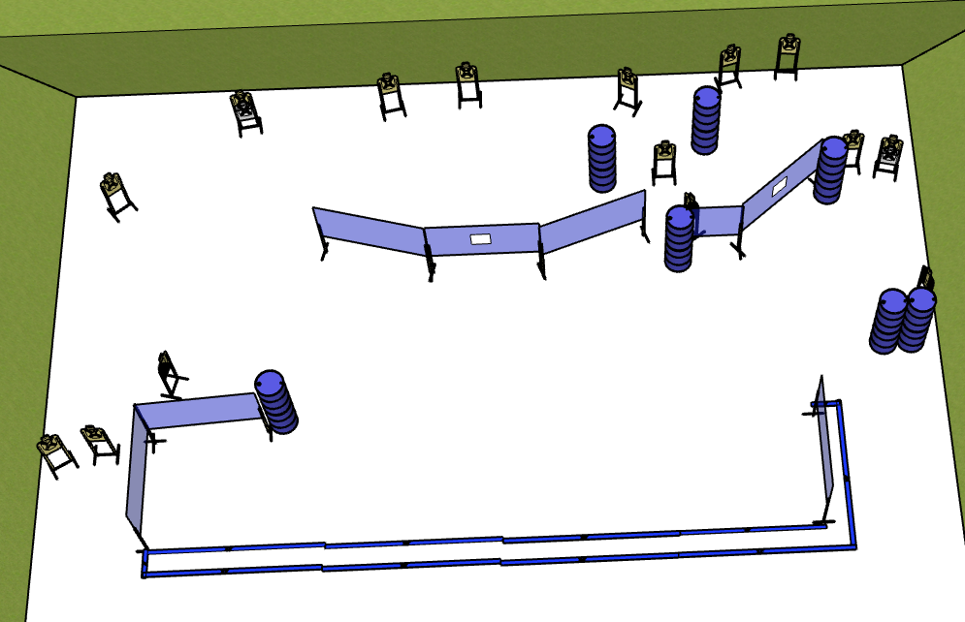

Written Stage Briefing:

Stage 2 – Any Port In A Storm - is a 30 round, 150 point, Comstock Course. There are 15 cardboard targets.

Starting anywhere completely outside of the shooting area.
Handgun is loaded and holstered, wrists below belt.
PCC is loaded held in both hands, stock on belt.

On the audible start signal, engage targets from within the shooting area.

USPSA / NROI Range Commands:
- Make Ready
- Are you ready?
- Standby
- If finished, unload and show clear
- If clear, hammer down and holster (Handgun)
If clear, hammer down and flag (PCC)
If clear, cylinder closed and holster (Revolver)
- Range is clear

Setup Notes:
8 Single Wall Stands
4 Double Wall Stands
5 Full Walls
2 Port Wall2
1 Half Wall
15 Target stands / 30 target sticks
14+ barrels


